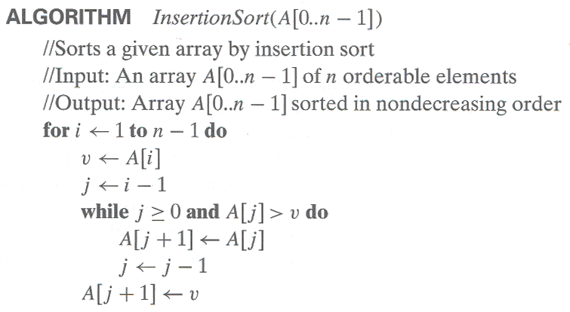**Problem 7.** We have studied the following algorithm for Insertion Sort:

1. [8 Marks] Using summations write exact formulas for the number of:
   1. Data comparisons in the worst case



* 1. Data comparisons in the best case

= (n-1)

* 1. Data assignments in the worst case

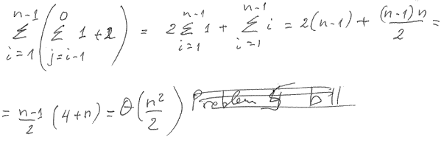

= n(n-1)/2+2(n-1)

* 1. Data assignments in the best case

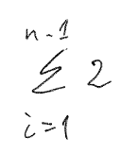= 2(n-1)